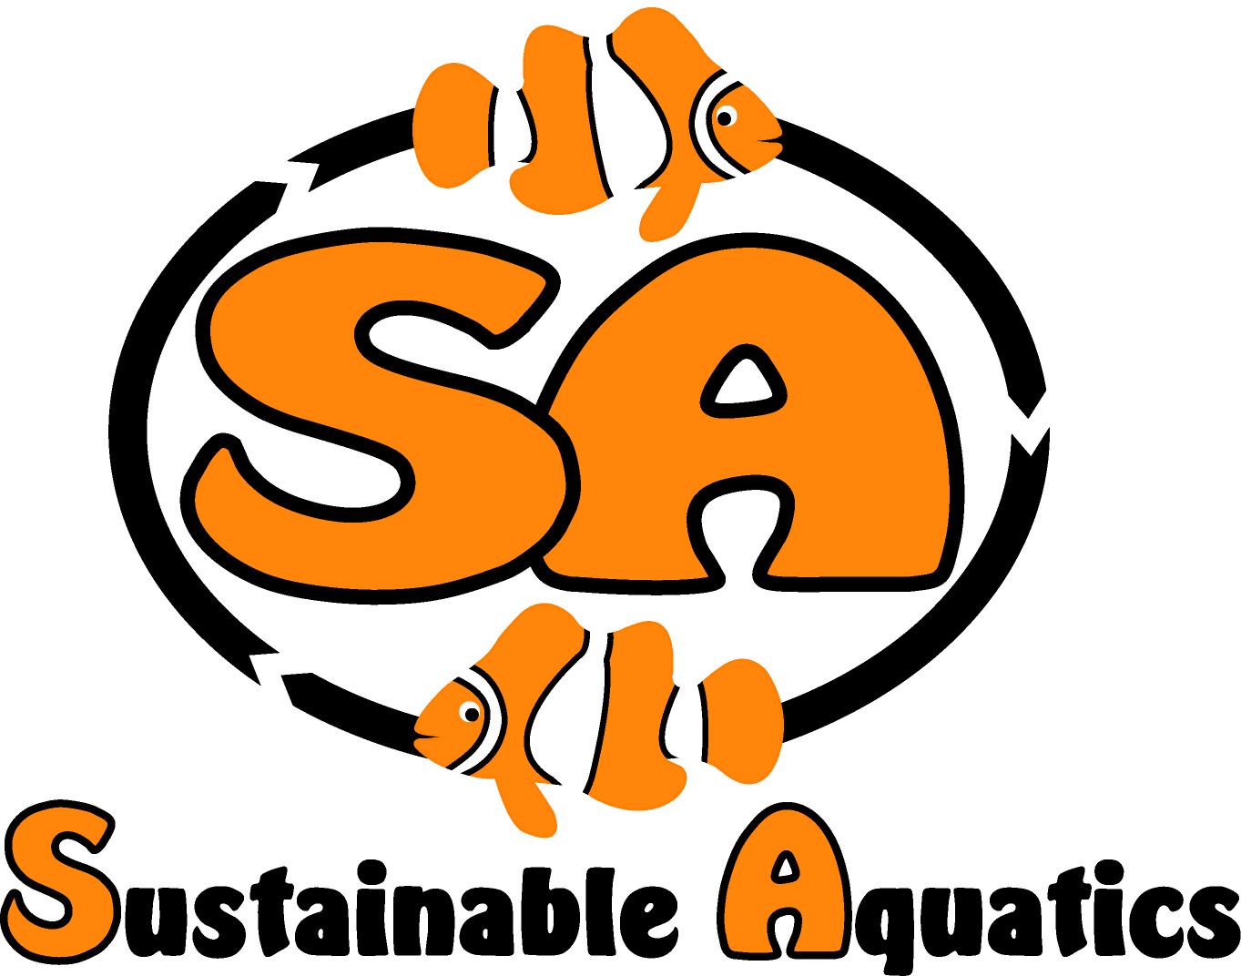 Sustainable Aquatics
110 W. Old Andrew Johnson Highway
Phone: (865) 262-0507 Jefferson City, Tennessee 37760 Fax: (865) 262-0498
25 September 2014

Updates and Perspectives on Acclimation:
John Carberry

Overview:

Many of the wild caught animals arriving at the Sustainable Aquatics’ (SA) campus have traveled great distances. They have often been in their bag’s shipping water for 40-60 hours. Over this time, great changes have occurred in the shipping bag’s water condition. Typically the temperature has changed, the pH has reduced by orders of magnitude as a factor the fish’s respiration. Over time the rise of the partial pressure of CO₂ in the water has risen and the pH has dropped from 8.2 to 6.4 or much less! This also reduces the pH of the fish’s blood, which must be properly managed. And of course great amounts of ammonia have been released by the animal. There can also be significant differences between the salinity and temperatures and alkalinity of the shipping water and the system water in which the animal is to be introduced. SA has evolved a simple acclimation process which over time has been validated by data with a great many different animals.

Our approach is based on several insights:

- Our observations while diving on many reefs world wide, combined with a great deal of literature, and our in house observations have proven to us that fish can adapt to changes in salinity quickly and safely;

- The same set of references have proven to us the same is true of temperature;

- Except for the dynamics of the ammonium/ammonia pH based equilibrium, we have observed the same with regard to pH; SA once raised a healthy batch of clown fish at a pH of 5.2!

- As the animal resides in the shipping water contained in the bag, several key dynamics take place:

- The animal’s respiration creates a fast growing partial pressure of CO₂. The rising CO₂ causes pH to dramatically fall, eventually acidifying to pH levels of 6 or lower.

- The animal excretes ammonia (NH₃) which at these lower pH levels is largely tilted in equilibrium towards ammonium (NH₄+), this ionized form of ammonia being fairly harmless to the fish. So in the bag, the lower pH is the animal’s friend!

Updates and Perspectives on Acclimation 25 September 2014
Page two

- Water has a much larger capacity to hold CO₂ than it does to hold oxygen. For instance there is about 8 ppm O₂ in sea water, but as the ocean acidification crisis demonstrates, the level in the seas rising towards 400 ppm.

- While the atmosphere has 210,000 parts per million oxygen, water is 1000 times denser. So while sea water only has 8 ppm oxygen, the oxygen content per unit volume of water, O₂ per cc for instance, is about 2-3% of what we breathe of air. We take up about 25% of the oxygen that passes our lungs, fish up to 80% but the amount of oxygen per unit time is similar.

- The physiology of fish respiration is very sensitive to several parameters compared to mammals:

- Water CO₂ levels affects the fish’s ability to exchange CO₂ for oxygen and raises CO2 levels in the blood, called hypercapnia. This also limits the fish’s ability to take up oxygen. This results in battling acidosis with ion exchange, the gills are highly permeable to proton transit, shedding H₂ and phosphorous ions and making bicarbonate. This is not thought to be harmful in the short term but is in the longer term.

- However it is important to note that a change in the fish’s water will change the pH of the fish’s blood too. Remember there is only a few cells separating the water from the blood. It takes time for the pH in the blood to adjust. So we want to avoid increasing the pH when there is ammonium present, but also give the pH of the fish’s blood time to adjust along with the water.

- Various fish have different gill structures and architectures, as well as different mucosa chemistry. This means some fish retain more ammonium in their gills and so are more sensitive to ammonia than others, due to these various gill sizes, architectures and types and thicknesses of gill mucosa.

- For instance the Tuna has a separation between the blood and the water of .6 microns, whereas more sedimentary fish may have a separation in the gill structures of as much as 1.6 microns.

- Adjusting the pH in the shipping water containing high levels of total ammonia before removing all gill entrained ammonium will result in the conversion in situ of the ammonium to ammonia, which burns the gills, and destroys the mucosa, resulting in short term stress or death, and long term vulnerability to bacterial infection. There is no place in fish physiology where the blood is closer to the outside environment than the gas exchange membranes of the gills, the separation being as little as .6 microns. (A micron is a millionth of a meter so .6 microns is an inch divided by 25,000…)

- Depending upon the time in the bag, the metabolism and size of the fish, the total available ammonia, TAM, called NHx here, level can be very high. We have measured in excess of 30 ppm. If the NHx level is very high in the shipping water, and in the form of NH₄+ it is relatively harmless. But it can become exceptionally lethal immediately upon opening the shipping bag. As the water with high NHx content is exposed to the atmosphere the pH of the shipping water will change very quickly, converting a large part of the NHx will become NH_{3.} This will burn the fishes gills quickly.
Updates and Perspectives on Acclimation 25 September 2014
Page three

- It is important to remember that changes in shipping water changes the pH in the animals blood and this takes time to adjust too, which is one of the factors for this

- So one must be very careful in acclimation to avoid exposing the animal to NH3 or shocking the animal with too rapid a change in pH while the animal’s blood pH is reduced. That is the subject of this paper.

Our process is very simple and direct and works very well:

- At SA we prepare “transition water”. The transition water is made using fresh RO water treated with salt to about 1.022 gm/cc, and with HCl to adjust this water to a pH less than 6.5, closely matching the pH of the shipping water, and to a temperature of about 78 F. This water contains no ammonia or ammonium.

- We also adjust the pH of the system water to the same level with HCl to a half-way point, about 7.2. In both cases we do not adjust pH with CO₂ as it is too sensitive to process variables and not stable long enough. The system water adjustment is temporary, overnight it will return to its former alkaline state.

- We bring we open the bag and lift the animal out of the bag and put it directly into the transition water. If an animal has been in a bag for two days it is safe to assume it is critical to get the animal out of the shipping water within seconds of opening the bag;

- The animal swims in the transition water for about for ten minutes or so. During this time the ammonium entrained in the gills is diluted to very low and safe levels the this ammonia/ammonium free water.

- We then put the animal directly into the system tank where the pH has been adjusted to a lower level of about 7.2. The system pH will return to the normal pH within a few hours.

Background and Basis of Key Points

Several years ago I spent about five hours snorkeling around a fairly large island on Marau Sound on the South West end of the famed Island of Guadalcanal. This area is very remote and very natural, a step back in time. The coral and animal populations diversity, density and health are stunning and cannot be found anywhere one finds any human development. During this long excursion I passed through both ends of a tide, and saw areas of the reef affected by upwelling’s, tidal flow from wetlands, from streams, and from the sea. I continuously saw ‘clines’ of pH, salinity, and temperature. And I saw all sorts of fish, every type, doing their business swimming repeatedly and rapidly in and out and through these clines. So I began to conclude that in terms of acclimation, our concern with pH, salinity and temperature must be based on observations of hidden inflections points and secondary derivatives. Mathematically, the etiology of all the stress and death and sickness from acclimation was not primarily pH, Temperature or salinity; it was in some way something caused by one or more of these factors. This could be an important insight.

We have also observed that different animals have differing reactions to acclimation and wondered why was this so? Clown fish, damsels, many tangs etc seem to have almost no reaction or stress from acclimation. Puffers, angels, anthias and wrasses seem particularly sensitive. We wondered why this might be so?
Updates and Perspectives on Acclimation 25 September 2014
Page four

We found much concern about adjusting salinity, yet the behavior we observed in the wild seemed to indicate the animals could adjust quickly and easily. We wondered what were the mechanisms, and what capacity or tolerance the animals had to salinity changes?

We wondered the same about temperature? What were the stress factors and what was important for acclimating and reducing the stress on fish coming in from long voyages.

- The ammonium/ammonia equilibrium:

Ammonia (NH₃) and ammonium (NH₄+) are two forms of the same species, differentiated into the two forms by pH and temperature. With regard to fish stress, at pH levels less than 6.2 the equilibrium is far in favor of more ammonium and does not stress the fish. At pH levels higher than 7 the balance favors ammonia and is lethal and dangerous to the fish:
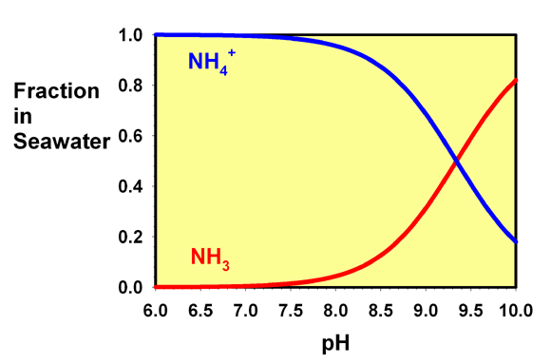

The Universities at Missouri Extension and Purdue both published the same work and tables, as shown and referenced, which follows a paper and study SA’s President and CTO, Matthew Carberry, did in high school some 15 years ago! They report that shipping water is often 14 ppm or higher with total ammonia and that pH is often 6.0 or lower. SA also reports these same observed values in countless shipments arriving from far off places to Jefferson City TN.

They teach that ammonia builds up, as described above, due to the excrement of ammonia resulting from both its normal and stress state metabolism of the animal. At the same time exhaled CO₂ causes a dramatic drop in pH, typically to between 5.5 and 6.4. Of the two forms of ammonia, the ionized, NH₄+ is relatively harmless, while the un-ionized form, NH₃ is very dangerous.
Sustainable Aquatics’ (SA) Sustainable Islands (SI) division imports wild caught fish from all over the world. We often measure total ammonia concentrations above 14 ppm and pH levels as low as 5.4. Depending upon the time of year and engineering of packing configuration (insulation, cold packs, heat packs, transit time, ambient temperature) the arrival temperature has been measured as low as
Updates and Perspectives on Acclimation 25 September 2014
Page five
54 F and as high as 92 F with fish surviving. All of our animals, both those sold from the hatchery bred lines and the tank acclimated or tank raised lines are from the equatorial and sub equatorial regions and cannot tolerate low temperatures. So we are forced to keep temperatures high where the equilibrium favors ammonia.
We see arrivals with total ammonia nitrogen (TAN) levels regularly at 14 ppm or higher, but most of this is benign ammonium. When pH rises the TAN equilibrium will tilt towards Ammonia, NH3, which is dangerous above 0.015, and when higher than .2 ppm ammonia is toxic and very harmful. Let us examine the table reported by Purdue and the University of Missouri:
Table 1
Percent of ammonia in the un-ionized form (NH₃ and balance is ionized form NH₄+) at different temperatures (degrees Fahrenheit) and pH values:

pH | Temperature
 | 50 | 55 | 60 | 65 | 70
6.0 | 0.02 | 0.02 | 0.03 | 0.03 | 0.04
6.5 | 0.06 | 0.07 | 0.09 | 0.11 | 0.17
7.0 | 0.19 | 0.24 | 0.29 | 0.34 | 0.43
7.5 | 0.59 | 0.74 | 0.93 | 1.07 | 1.33
8.0 | 1.83 | 2.30 | 2.87 | 3.31 | 4.10
8.5 | 5.56 | 6.92 | 8.54 | 9.78 | 11.90
9.0 | 15.70 | 19.00 | 22.80 | 25.50 | 29.90

So if we assume that the incoming bag has 14 ppm total ammonium, but that with a pH of 6.0 or less the vast majority of it is relatively harmless ammonium, there is less than .006 ppm ammonia. So the fish is unharmed. But raise the pH to 6.5 and we enter the danger zone of 0.015 ppm. Then it rises catastrophically as shown in this table: at 7.5 pH it is lethal, at 8.0 it is deadly:

pH | Ammonia (NH3)
at 70 ºF | (% of TAN) | (PPM)
6 | 0.04% | 0.0056
6.5 | 0.17% | 0.0238
7 | 0.43% | 0.0602
7.5 | 1.33% | 0.1862
8 | 4.10% | 0.574
8.5 | 11.90% | 1.666

Ammonia (NH3) ppm based on" total ammonia nitrogen" (TAN) of 14 ppm

Updates and Perspectives on Acclimation 25 September 2014
Page six

When an animal has spent an extended period of time in the closed environment of the shipping bag, expelling of CO₂, this growing partial pressure of this gas, dramatically reduces the pH of the shipping water. This actually saves the animal’s life from the toxic amounts of ammonia being released. As the pH descends the NH₃ takes the nontoxic form of NH₄+ and the animal is protected.

But the levels of total ammonia (TAN) rises to exceptionally high levels, as high as 14 ppm or higher. Nontoxic as NH₄+ even in these exceptionally high levels, a rise in pH converts relatively small amounts of NH₄+ to NH₃. While the animal can tolerate 14 ppm NH₄+ or higher, once the pH rises much over 6.5, NH₃ reaches and exceeds 0.015 ppm, compared to 14 ppm of the NH₄+. The chart below shows how dramatically the NH₃ ppm is affected by a rise in pH.

This means that one must reduce the presence of ammonium by about a factor of perhaps 300 before allowing the pH to rise so to avoid its conversion into even 0.015 ppm NH₃.

Per LaDon Swann, Purdue University, NH3 should be viewed with caution at 0.015ppm, and is extremely toxic at 0.2 ppm.

So clearly one needs to remove almost all ammonium from the fish gills and mucosa and from the shipping water in which the fish is residing before adjusting the pH even a little bit. Some key points:

- Drip acclimation is perhaps the worst way of acclimating fish in shipping water with a low pH and heavy TAN (total ammonia nitrogen).

- Leaving the shipping water open to air can have the same effect of drip acclimation, as it allows the CO₂ to release and reach equilibrium with the air and results in rise in pH which will result in conversion of the ammonium to ammonia and hurt the animal;

- Some prefer acclimating by removing half of the shipping water and replacing with fresh water. This is less harmful that the two above. But it is best to remove the fish from all ammonium and clear the ammonium in all forms and ways before allowing the fish to enter water at higher pH.
Updates and Perspectives on Acclimation 25 September 2014
Page seven

- Shipping Water pH and Ammonium Content, Buffers and Ammonia Absorbents:

Our data on incoming shipments comes from places faraway from Tennessee, for instance Kenya, Madagascar, The Red Sea, the Solomon Islands, Fiji, Bali, the Philippines, Hawaii, the Marshall Islands, Christmas Islands, Tonga, the Caribbean and many other places. During these long transit times total ammonia rises to 14 ppm and higher and the pH drops to 6.4 or lower.

We also ship fish, including our hatchery bred animals all over the United States and the world, and we observe the same events. From the SA and SI facilities we use shipping water for half of the water shipped, and this is fixed with a buffer and an ammonia absorbent.

Most of our incoming wild fish from collection stations are not fixed with buffers and ammonia absorbents. Still, measuring the pH and the total ammonia content will guide one as to what must be done in these regards. When high levels of ammonium are present at low pH our suggested method seems the only safe and reasonable approach.

- Variations in Fish Gill Size, Architecture and Mucosa chemistry;

A recent National Geographic article pointed out that Atlantic Blue Fin tuna have a gill structure and size in scale 30 times larger than the normal fish. G. M. HUGHES of Department of Zoology, University of Bristol in his 1966 paper THE DIMENSIONS OF FISH GILLS IN RELATION TO THEIR FUNCTION J. Exp. Biol. (1966), 45, 177-195 reported that there are very significant difference in gill size, geometry and architecture. He concluded that more active fish had larger more complex gills. David Randall’s landmark paper: THE CONTROL OF RESPIRATION AND CIRCULATION IN FISH DURING EXERCISE AND HYPOXIA, J. exp. Biol. (1982), 100, 275-288 is an excellent tutorial. As is Perry and Gillmour in their paper Acid–base balance and CO2 excretion in fish: Unanswered questions and emerging models Respiratory Physiology & Neurobiology 154 (2006) 199–215, and William A. Wurts and Robert M. Durborow in their paper, Interactions of pH, Carbon Dioxide, Alkalinity and Hardness in Fish Ponds, published by SRAC December 1992.

- Effect of Ammonia on Fish Gills:

When ammonia rises much above 0.015 ppm for any period of time it attacks and destroys the mucosa on the gill structures and the eyes and other places as well. This is a chemical burn. It causes stress in the animal, and possibly immediate death. It can also result in delayed morbidity as the destruction of the mucosa exposes sensitive tissue, where the barrier between the environment and the blood is as thin as possible and thus opens up venues for bacterial infections.

- Marine Fish Regulate External Salinity Exposure Through Internal Osmosis Regulation

J. S. GIBSON et al in J. exp. Biol. 128, 371-382 (1987) 371 taught I in their paper SALINITY ACCLIMATION AND INTESTINAL SALT TRANSPORT IN THE FLOUNDER: THE ROLE OF THE BASOLATERAL CELL MEMBRANE the mechanisms in osmotic regulation in response to changes in the external salinity environment. It is clear from this work that the animals have strong function to react to and regulate the osmosis processes to follow their movements through variations in the salinity of their environment.

Updates and Perspectives on Acclimation 25 September 2014
Page eight

- Ability of Marine Fish to Adjust from Temperatures outside of Optimal Native Temperatures quickly and without Stress

There is no question in our mind that fish can adjust quickly to changes in temperature. However, we have learned that in shipping fish, temperature is one of the most important factors in shipping success. Most all our animals are tropical and they like something in the range of 78 degrees F and excursions from this set point always eventually leads to trouble. And the longer the excursion the larger the trouble.

We have learned much about the enzyme and amino acid processes so important in a fishes blood chemistry and endocrinal processes. Each animal, fish or other, has an optimal set point temperature at which their enzyme and amino acid and blood system and endocrinal system optimally operates. When the fish arrive if they are a tropical fish especially, and the arrival temperature is low, they need to be returned to their optimal set point temperature as quickly as possible. Time is not a friend of this animal in making the adjustment.

It is informative to remember that cyanide interferes with the enzyme functions in the blood system and the endocrinal systems. The animal processes try, if they have enough time to eliminate the cyanide by converting thiosulfate into thiocyanate. So, a fish which has an optimal set point at 78 F, but spends a lot of time in shipping at perhaps 68 F, is suffering compounded stress from both the cyanide and the temperature. So the quicker we get the fish to the optimal temperature the better. In this case the transition water is set to the optimal temperature, and the fish is immediately moved into this temperature.

These variables are interacting, and interdependent. So observations made without context of all the variables may result in incorrect conclusions. It seems to us that the driving variable in this case is adjusting pH without allowing a catastrophic increase in the portion of the ammonia in the species of NH3. If one can manage that part of the process, adjusting temperature, salinity and pH can be done quickly and the quicker the better.

Tools required for success:

- An ammonia test kit to sample shipping water;
- A pH meter to accurately measure pH in adjusting transition water and adjusting shipping water, as well as measuring incoming shipping water;
- A clean pure HCl for adjusting pH;
- Appropriate goggle or face mask, gloves and safety equipment as well as appropriate storage for the acid.
- An appropriate sized tank for transition water. We often use agricultural tanks 52 inches long, 31 inches wide and 12 inches deep:

