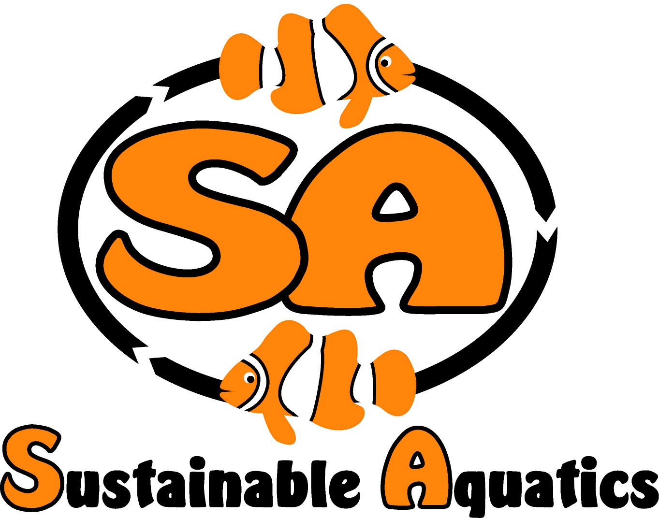
Now Available from Sustainable Aquatics!

Sustainable Aquatics 110 W. Old Andrew Johnson Highway - Jefferson City, Tennessee 37760

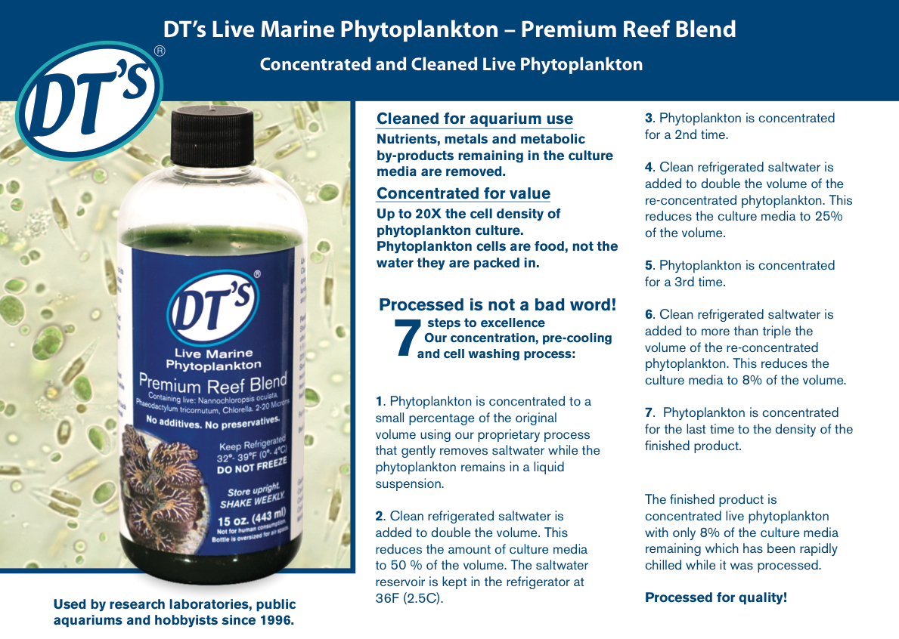
Phn: (865) 262-0507 Email:sales@sustainableaquatics.com

