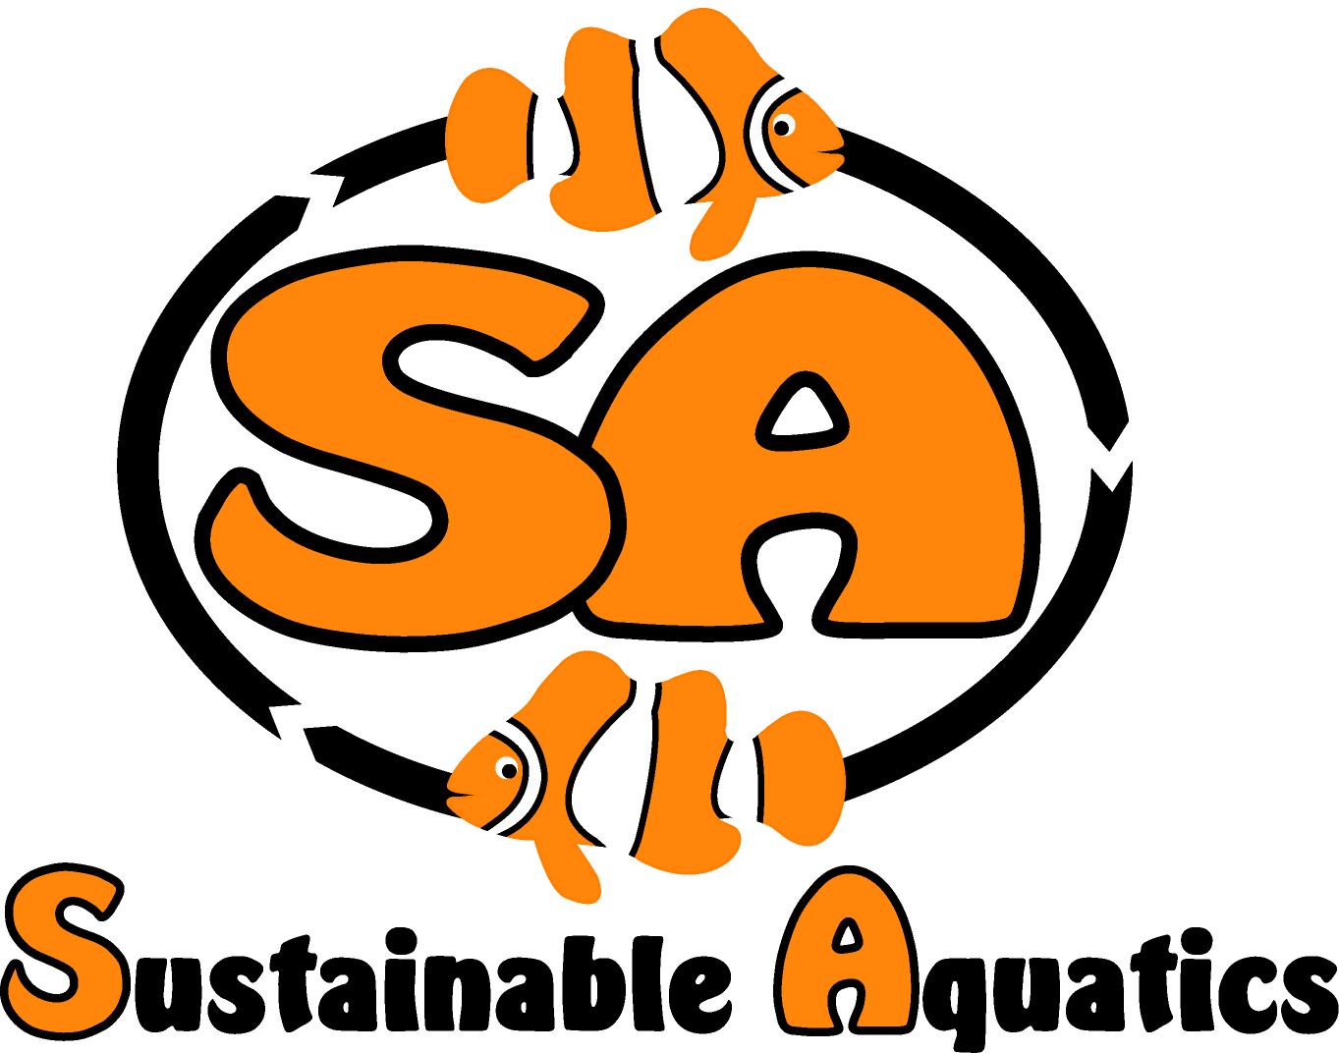 Sustainable Aquatics
110 W. Old Andrew Johnson Highway
Phone: (865) 262-0507 Jefferson City, Tennessee 37760 Fax: (865) 262-0498
28 April 2014

Fish Loss Management: Why Do So Many Fish Die in the Marine Ornamental Live Fish Trade?

If our industry, the marine ornamental industry, is to survive or thrive, we must do five things:

- Track fish survival from catch or hatchery origin through the supply chain and chain of custody to successful acclimation in the hobbyists care and bring yields towards 100%;

- Learn the causes of losses in the supply chain and chain of custody and track each down to root causes;

- Implement systemic solutions that reduce losses as close to zero as possible;

- Create transparency and auditable objective standards and reports as to actual systemic performance;

- Invest in a proactive positive portrayal to the general and specific worlds of the ways in which our industry is making important contributions to sustainability, understanding our ecosystems better, and celebrating and enhancing the human animal bond.

Industry statesmanship and leadership is required to successfully accomplish these things. Sustainable Aquatics (SA) and its Sustainable Island’s Division is investing great resources for several years so to focus on collecting real data and solve these challenges, always remembering the plural of anecdote is not data, it is anecdotes! Collecting auditable data is critical to moving forward.

Question 1: What are the losses in the supply chain from catch to hobbyists successful acclimation?

As an industry we claim we do not know. Estimates range as high as 65%, many report 35% in narrow portions of the supply chain, for instance retail. When SA’s Sustainable Islands Division brings in fish caught with cyanide and hold them for three or more weeks, typical losses are in the range of 30-70%. When we bring fish in that are caught cyanide free, our losses are in the range of 2-5% max. Most wholesalers do not keep the animals for more than a few days, and so do not know or track systemic losses. We think we know how we as an industry should be processing fish that will have very high survival. Measuring thiocyanate in shipping water is a very promising candidate. (Recently I was challenged by this method, my challenger maintained one could find thiocyanate in fish not caught with cyanide since there can be some run off of cyanide from silver and gold mining. This person has no technical expertise and was not basing his opinion the work of anyone who had technical expertise. He was in fact creating an anecdote. The difference is orders of magnitude.)

Whatever the causes of these extraordinarily large losses in our supply chain, holding fish for 21 days and assuring fish are fed and caught cyanide free and acclimated properly, does seem to work, assuring success.

Question 2: What are the causes of losses in the supply chain?

Again, the industry seems to claim we do not know. Sustainable Aquatics have worked hard to collect data and understand the causes of losses and have reduces losses to single digits, not including shipping disasters. We have identified four key interacting variables that we believe are the cause of most all losses:
Fish Loss Management 28 April 2014
Page two

- Most of the marine ornamentals sold in the Unites States and abroad are caught in the “coral triangle”, and the vast portion of these are imported from the Philippines. Our own government estimates that 90% of the marine ornamentals caught in the Philippines are caught with cyanide. Cyanide is both a quick and slow killer, it kills quickly by asphyxiation. It kills slowly by interfering with enzyme functions in the blood and endocrinal systems. The quick death happens to many fish, invertebrates and corals at the catch site. The slow death takes up to a month, and often happens later in the process after feeding through toxic shock. (Please see our white paper on cyanide.)

- Reef dwelling fish do not store energy very well, and are constantly eating. Many of the specimens collected are juveniles and typically using two thirds of diet for energy and one third as substrates for growth. Starvation induces ketosis from which they often cannot recover. (Please see our presentation on fish feeds.) We find large losses occur if fish are in the supply chain for more than five days or so without feeding, which can be a common event.

- Acclimation of fish shipped long distances may not be so very well understood: The key metric in acclimating a fish shipped a long distance is to remove the ammonium ion (NH4+) from the shipping water before the pH lowered by the respiration of the animal expelling CO2 is raised. Ammonium is relatively harmless to the fish, and different fish entrain different amounts of NH4+ in their gills and the mucosa on their gills. If this entrained NH4+ is not removed and the pH is raised the result is an insult to the animal’s gills and the destruction of the gill mucosa. This mucosa is one of the most important barriers and protections to pathogens and if compromised in a fish exposed to cyanide catching methods the rise of disease is inevitable and a dangerous pathogen vector. (Please see our white paper on acclimation.) Downstream losses will occur once this insult is administered.

- The “set” temperature for most animals is that temperature at which their enzymes and amino acids and other molecular biology functions are most efficient. Shipping experiences where there are large and especially long periods of temperature excursions, especially when combined with one or more of the other three input variables, will also compromise the fish and challenge its survival. So protecting fish during transits from long term temperature excursions is important.

Question 3: What are the costs of these extraordinary losses in our supply chain?

The use of cyanide, and the losses associated with cyanide, starvation and ketosis, improper acclimation, and poor handling in the supply chain have an extraordinary cost to us in several ways:

  - There is very substantial damage to the ecosystem due to collateral death and destruction to the non targeted fish, invertebrates, corals and other members of the ecosystem;

  - We end up collecting many more animals, and damaging much more of the ecosystem that would be necessary if we did not have these losses;

  - We pay a much higher cost of doing business to cover the costs of the losses;

  - Since many of these losses happen in the care of hobbyists, we alienate a large portion of our customer base, who SA believe leave the hobby never to return;

  - We expose ourselves to attack by our adversaries and risk our businesses and reputation;

  - We fail to do our best and meet the highest standards we must define and serve if we are to build a credible business and industry about which we can and should be proud.

Fish Loss Management 28 April 2014
Page three

Question 4: How do we proceed and find and implement solutions?

Back in the late 70s and early 80s I was working in the semiconductor industry. Given that the volumes of PCs and devices we were looking forward to building it became clear that we had to learn build in quality and cease inspecting quality in at final QC inspections. In a four year period I witnessed brute force inspection removing 5% rejects, (50,000 parts per million) reduced to Six Sigma (3.4 defects per million.) We learned formalized problem solving (Plackett Burman for instance) statistical process control and characterization, herring bone analysis, process capability, variation analysis, we learned from Dr. Deming, Bill Sherkenbach and many others. We learned many lessons:

- The difference between anecdotes and data;

- The need for complete data collection and characterization;

- The need to stabilize processes to prepare them for process improvement and optimization;

- The need to look at the total process, from raw materials to finished semiconductor devices, we learned we needed to break down the barriers between our companies and look and characterize and control and improve the total process.

When we began SA we decided to be process engineers doing biology and we set a goal to approach 100% yield on eggs to sale. We are in the high 99% territory now for some time. We have the data and process engineering systems in place to subject this to audit. As we have learned to deal with live fish in the SI Division we have also learned to go to the sources, examine practices and collect data and characterize process in the entire supply chain from collection and handling in the wild, logistics, acclimation, cyanide, nutrition, retail (this is why we operate a retail store in Knoxville), again seeking nearly 100% yield. It is achievable and we are approaching this goal.

Problem solving is fun and productive. We do not see how our industry can survive with current practices and yields. We must do the following:

- Commit to eliminating cyanide from wild collections. SA is prepared to bring the physics and chemistry and practices to prove in laser liquid chromatography as a reliable screening tool;

- In the meantime, the 21 day holding test has proven exceptionally effective at qualifying and disqualifying cyanide free catching. Given our ongoing work to understand the Lacey Act, let it be said it probably screens for many things including cyanide, but cyanide it is!

- Commit to collect data on all suppliers and participants in the supply chain, from catchers to shippers to wholesalers, hatcheries, distributors and retailers and even hobbyists, to understand the process and the yields;

- Use this data and team work to do formalized problem solving, statistical problem solving and process engineering and control to do the best we can do, which is much better than we are currently doing.

Respectfully,

John Carberry

