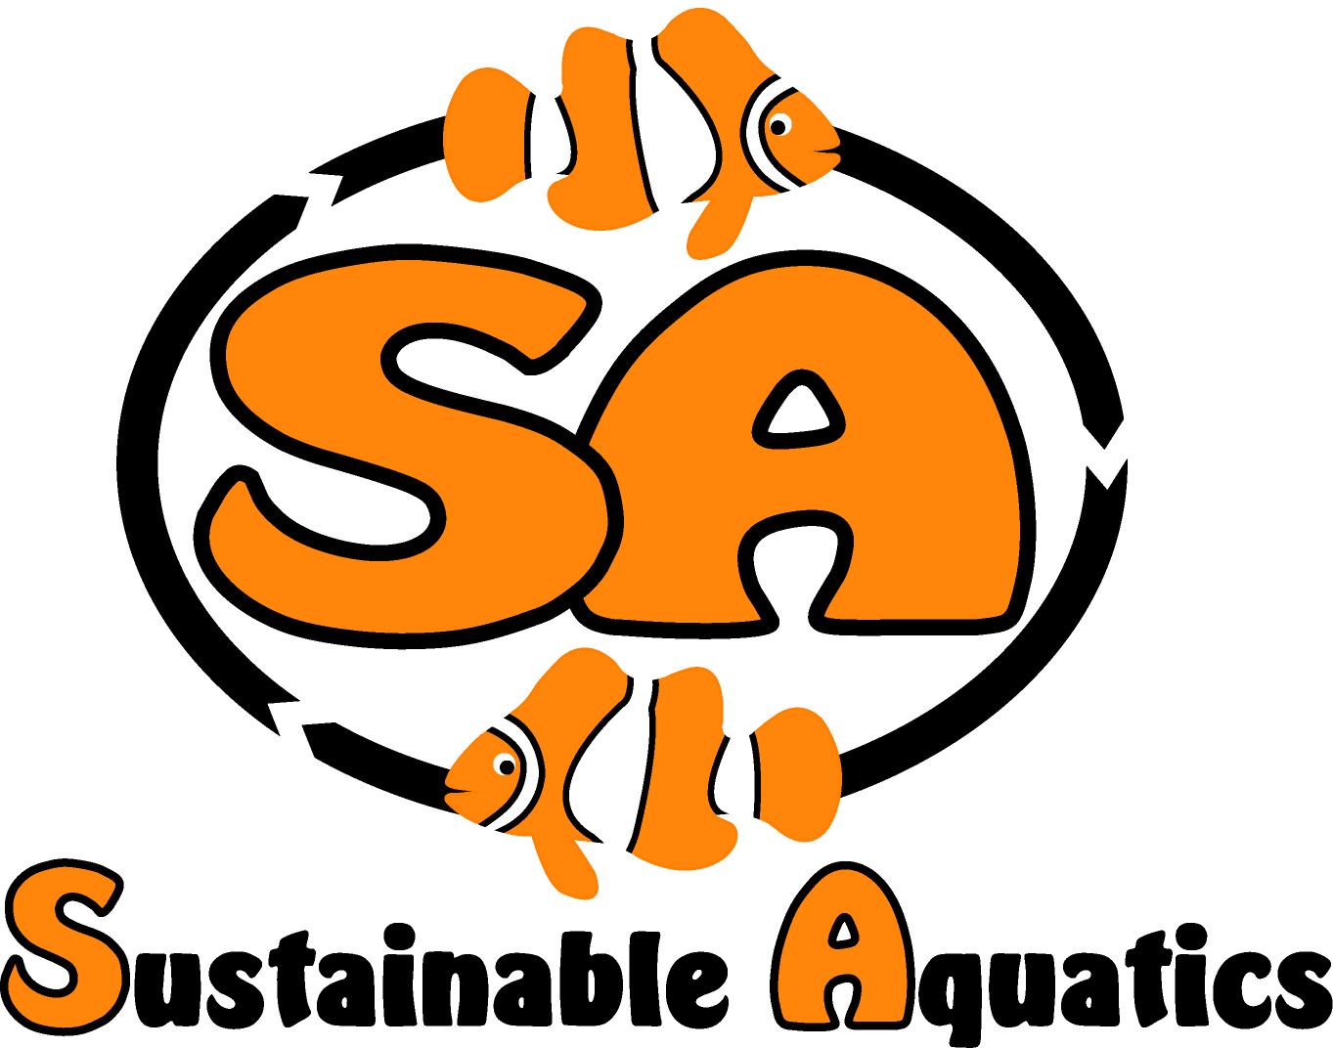 Sustainable Aquatics
110 W. Old Andrew Johnson Highway
Phone: (865) 262-0507 Jefferson City, Tennessee 37760 Fax: (865) 262-0498
Introducing Sustainable Aquatic’s “Wheely Complete Pro C”!

Bio wheels with high surface area have long been recognized as the ideal processer of ammonia and nitrites. But they have not been widely available economically on a stand-alone basis to all segments of the markets. Wheely Complete Pro C, SA’s first entry into this important product line, fills this long standing unfulfilled need of pet stores, hatcheries, maintenance accounts, larger fish systems, breeders, public aquariums, wholesalers and large fish tank keepers.

Wheely Complete Pro C delivers groundbreaking value in processing ammonia, nitrites, controlling CO2 and pH levels and increasing oxygenation, optimizing performance in fish systems found in hatcheries, koi ponds and tanks, large display fish tanks, pet stores, public aquariums and fish holding systems.

SA are installing hundreds of Wheely Complete Pro X units in the SA Hatchery in the coming months: they are having a dramatic effect on ammonia, nitrites, O2 and CO2 levels, water changes and fish health and growth on all systems. SA now have a patent pending for this exciting new approach to designing and making this product, lowering costs with improved designs and performance. We offer it for the first time with general availability at a very attractive cost.

Using Wheely Complete Pro C:

- Processing ammonia (NH3) into nitrites (NO2): Wheely Complete Pro nurtures very large healthy populations of aerobic autotrophic nitrosomanas bacteria, which very efficiently process NH3 into NO2. This is the 1st step in cycling and leads to the 2nd step: as ammonia levels fall nitrobacter bacteria begin thriving;
- Processing nitrites into nitrates (NO3): Once the ammonia levels have settled down, the 2nd step in cycling happens: aerobic autotrophic nitrobacter bacteria are able to grow, processing nitrites into nitrates. Nitrates, unlike ammonia and nitrites, are not so toxic to fish. A NO2 spike often happens as this begins.
- Scrubbing carbon dioxide (CO2) from the water: Wheely Complete Pro efficiently removes CO2 from the water, which aids the fish and helps control pH;
- Oxygenating: Large quantities of oxygen are required for healthy fish and for strong healthful bacteria cultures; Wheely Complete Pro C pulls O2 from the air, so bacteria do not compete with the fish for oxygen and high O2 levels are maintained;

Wheely Complete Pro C and related nitrogen cycle notes:

- Each Wheely Complete Pro C is designed to sit in your sump and receive the return water over an easy to clean filter pad on the top tray; This filter pad can be cleaned regularly in a few minutes.
- Each unit comes with adjustable legs, which are cut to water depth less up to one inch, so to position the unit in the sump water so the water in the bottom tray under the wheel overflows into the surface of the sump water;
- Simply shake out the wheel in a bucket of tank water every few months;
- Heterotrophic bacteria can survive being dried out, autotrophic cannot; so if the wheel stops and dries out, sterilize it and start from scratch;
- Heterotrophic bacteria reproduce as quickly as every 12 minutes, autotrophic in as long as 20 hours. In twenty hours one autotroph can double, the heterotroph can reach a million!
- If you find water cloudy during cycling, this could be an explosion of heterotrophic bacteria, not a good thing;
- Optimal conditions for autotrophic bacteria: pH in the range of 7.7-8.4, temperature mid-70s to mid-80s.
- Heterotrophic bacteria consume organic matter as food, autotrophic do not, make their own food, and need other sources of carbon; therefore higher alkalinity levels, with carbonates, aid healthy cultures of autotrophic bacteria and reduce the build-up of “slime”.
- The minimum space required in the sump is 12 inches high, 8.5 inches wide and 15 inches long. No power other than the flow of return water is required. Full cycling takes a few to several or more weeks.
- For the first time this type of unit is available on a stand-alone basis at a very attractive price for all applications: Koi, gold fish, cichlids, fresh water of all type, marine fish, ponds, large and small systems all!

